**Data Structures Lab 2 Report**

Group Members: Vivek Kunapareddy, Yuan Cheng

1. The concepts explored in this lab were: File I/O and Object oriented programming(Class design and instantiating objects)

These concepts are important in this class as most of data structures will involve some sort of OOP concept or class design. This assignment helps us get a strong grip on fundamentals for when we will be experimenting later on in this course.

These concepts will be extremely helpful when moving into the workforce as most modern programming involves OOP and File management especially in a field such as Embedded Systems.

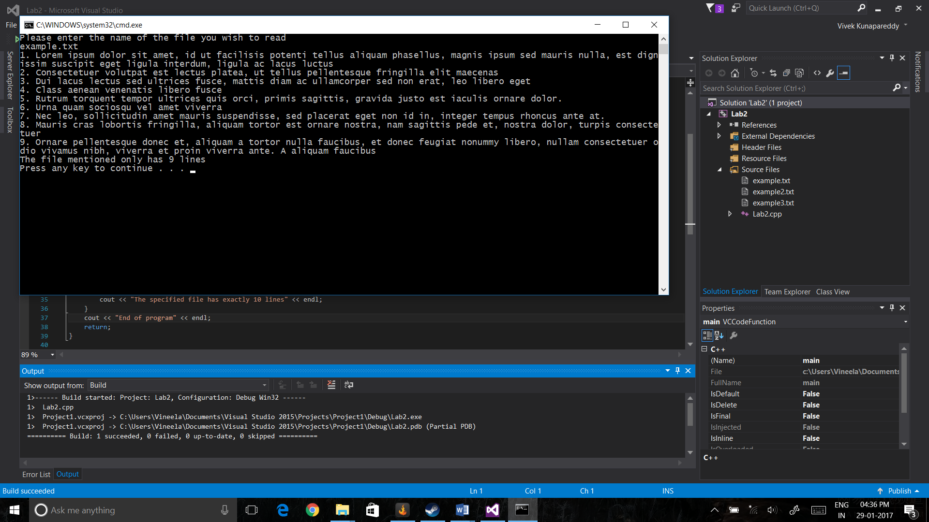

Task 1 – Output with 9 Lines

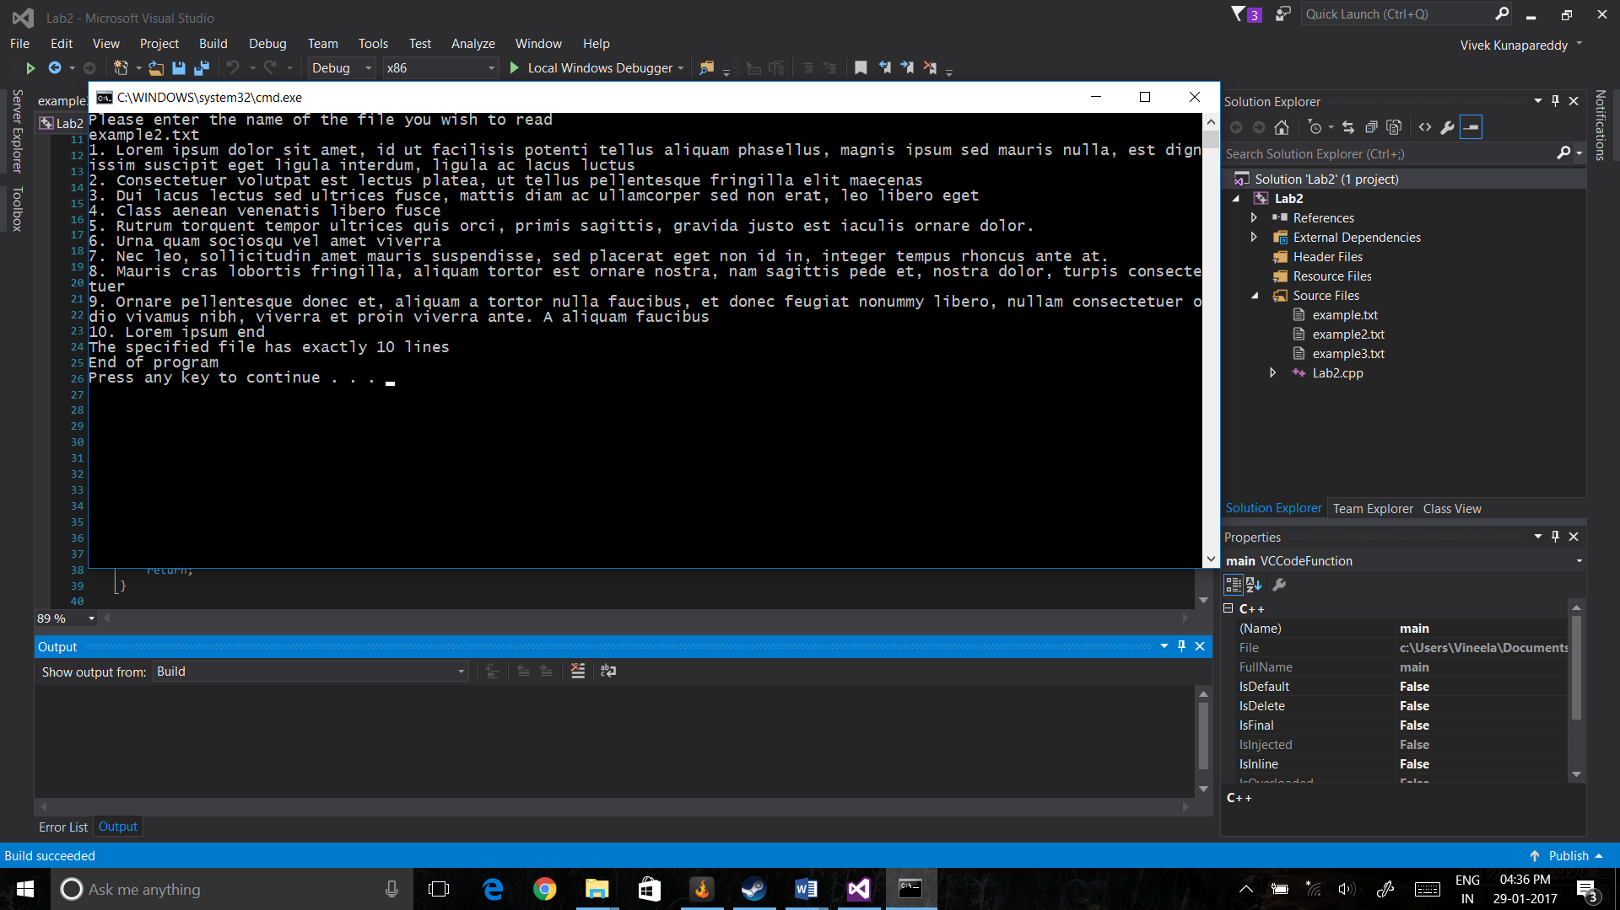

Task 1 – Output with 10 lines

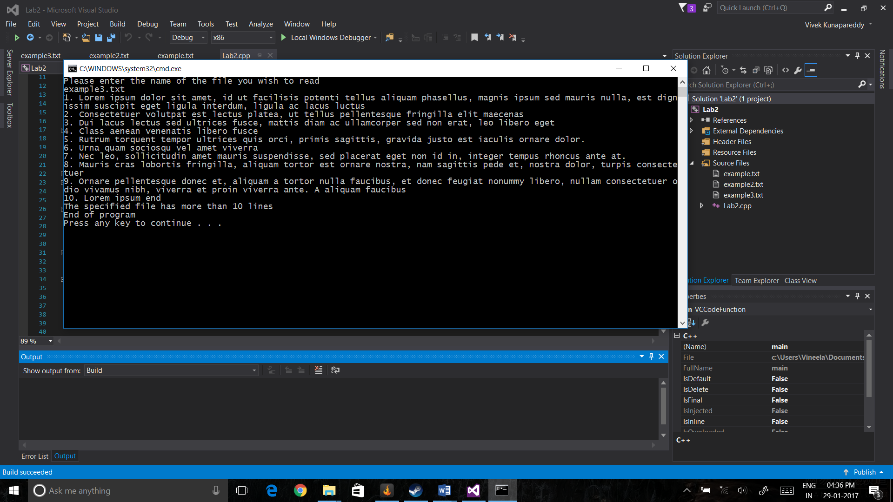

Task 1 – Output with 11 Lines

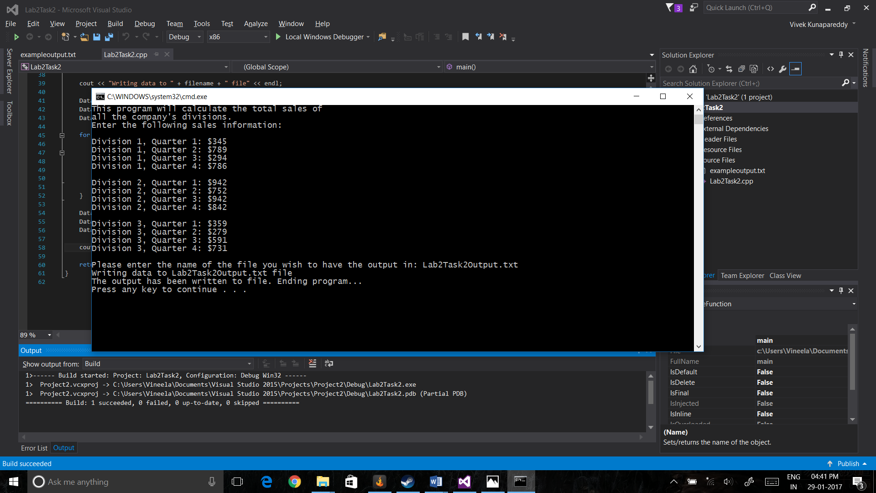

Task 2 - Output

1. The file access flags used for the most part were ios::app as this allowed to use a single flag to both create non existing files and also append output to existing files. The ios::in flag was used to read input from the file in task 3 too. The ios:: binary flag was disregarded for this lab as we didn’t need to deal with binary data. The ios::trunc and ios::out flags were also not used as they delete existing data in the file which was not required.
2. The class design was extremely simple in Task 3 as it just includes 4 private member variables pertaining to information about the product. And the public member functions include getters and setters for each member variable. The reason for the simple design was to encase the logic used in the main file instead of in the class. Thus making them reusable. Also the getters and setters were included to allow access to the member variables.
3. The testing in Task 3 was done by checking if the file inputted existed, and then counting the number of lines in the file. This was done as the number of products was fixed beforehand. If the number of products was lesser or more than the required number, an error message will be outputted to the console. The test cases were considered before writing the code as they were specified in the requirements

Group Contributions:

The entire programming was done as a pair during the lab

The class design was done by Yuan

The file I/O logic was handled by Vivek

The debugging was done together while pair programming